# **Final Year Project: Multiplayer Online Game with AI - Progress Report**

## **Progress Chart**

|  |  |  |  |  |  |  |  |  |  |  |  |  |  |
| --- | --- | --- | --- | --- | --- | --- | --- | --- | --- | --- | --- | --- | --- |
| **Agenda\Week** | **1** | **2** | **3** | **4** | **5** | **6** | **7** | **8** | **9** | **10** | **11** | **12** | **13** |
| Determine project direction |  |  |  |  |  |  |  |  |  |  |  |  |  |
| Find out feasibility of Mahjong AI |  |  |  |  |  |  |  |  |  |  |  |  |  |
| Explore Unity |  |  |  |  |  |  |  |  |  |  |  |  |  |
| Study Machine Learning |  |  |  |  |  |  |  |  |  |  |  |  |  |
| Research on TensorFlow & Pytorch |  |  |  |  |  |  |  |  |  |  |  |  |  |
| Research and understand Machine Learning agents (ML-agents) in Unity |  |  |  |  |  |  |  |  |  |  |  |  |  |
| Try out demo game using ML-agent in Unity |  |  |  |  |  |  |  |  |  |  |  |  |  |
| Identify methods to train the AI (Tic Tac Toe) |  |  |  |  |  |  |  |  |  |  |  |  |  |
| Understanding the of various data types seen in examples |  |  |  |  |  |  |  |  |  |  |  |  |  |
| Implementing the logic required by the AI |  |  |  |  |  |  |  |  |  |  |  |  |  |
| Write and troubleshoot the script for the AI gameObject |  |  |  |  |  |  |  |  |  |  |  |  |  |
| Training and troubleshooting the AI script with existing .yaml trainer file. |  |  |  |  |  |  |  |  |  |  |  |  |  |
| Edit the Tic Tac Toe script for faster training and troubleshoot errors |  |  |  |  |  |  |  |  |  |  |  |  |  |
| Create documentation for Unity ML agents |  |  |  |  |  |  |  |  |  |  |  |  |  |
| Plan AI for Phase 2 of Project (More complex game) |  |  |  |  |  |  |  |  |  |  |  |  |  |
| Discussion regarding difficulties faced and the ideal game structure |  |  |  |  |  |  |  |  |  |  |  |  |  |
| Discussion regarding difficulties faced and the ideal game structure |  |  |  |  |  |  |  |  |  |  |  |  |  |

## **Tasks Completed**

|  |  |  |
| --- | --- | --- |
| **Date** | **Number of hours** | **Task Completed** |
| 01-NOV-20 | Ongoing | Edit the Tic Tac Toe script for faster training and troubleshoot errors  Running game in parallel to speed up training |
| 01-NOV-20 | Ongoing | Plan AI for Phase 2 of Project (More complex game)  Currently decided on GinRummy due to similarities with Mahjong |

## **Problems Faced**

1. At 140k steps, the AI still does not feels smart enough.

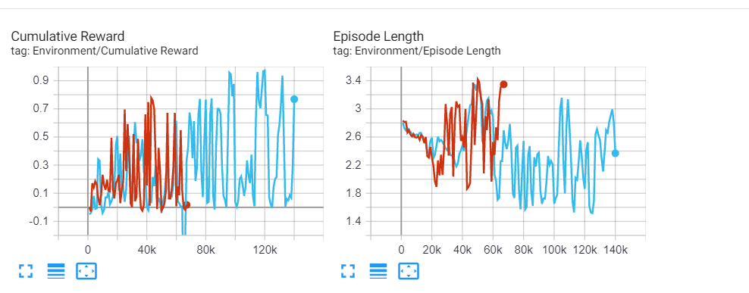

* 1. Refer to the code found online and run training to see the difference. The code was able to play TicTacToe very well.

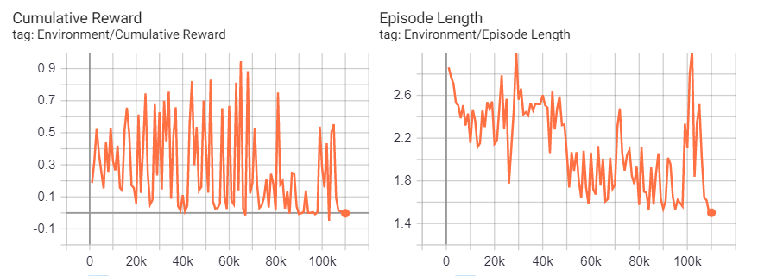

* 1. Our code can train the AI 1k steps every 3mins, the example online is able to train the AI 1k steps every 9 seconds. It was stated that the AI was trained 3 hours to be able to play like a human. With the data given, our training is 18times slower, thus to reach the same level of playing prowess, 24hours of continuous training is needed to see the AI competency.